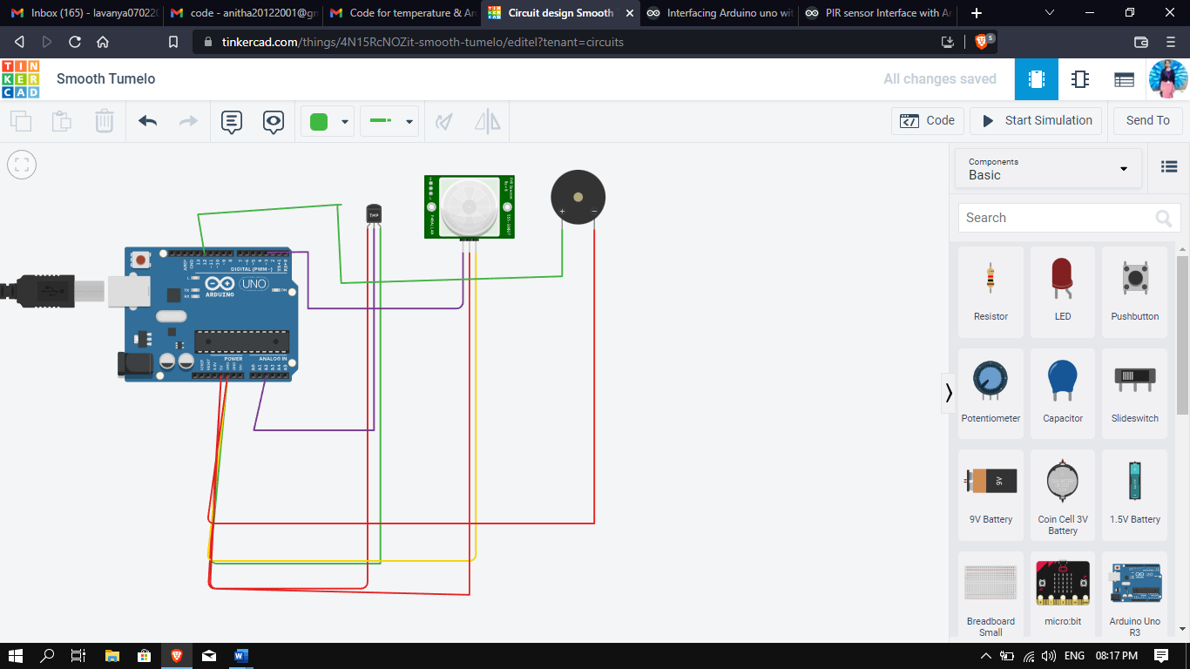

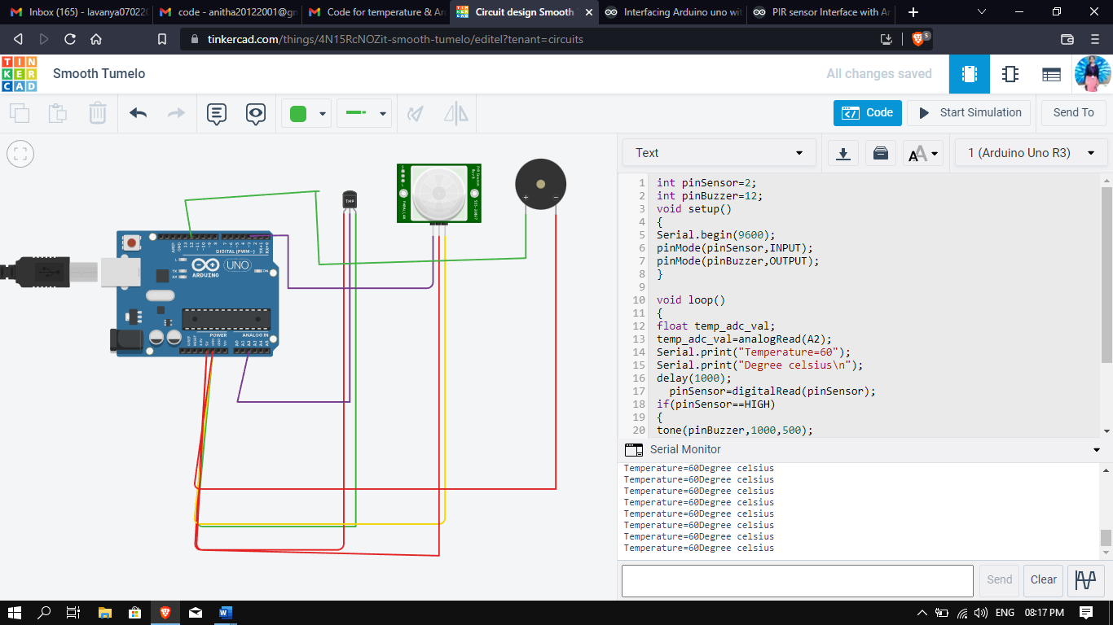

**CODE**

|  |  |  |
| --- | --- | --- |
|  | int pinSensor=2; int pinBuzzer=12; void setup() { Serial.begin(9600); pinMode(pinSensor,INPUT); pinMode(pinBuzzer,OUTPUT);   }  void loop() { float temp_adc_val; temp_adc_val=analogRead(A2); Serial.print("Temperature=60"); Serial.print("Degree celsius\n"); delay(1000);   pinSensor=digitalRead(pinSensor); if(pinSensor==HIGH) { tone(pinBuzzer,1000,500); } delay(10); } |  |